1. Personal Details
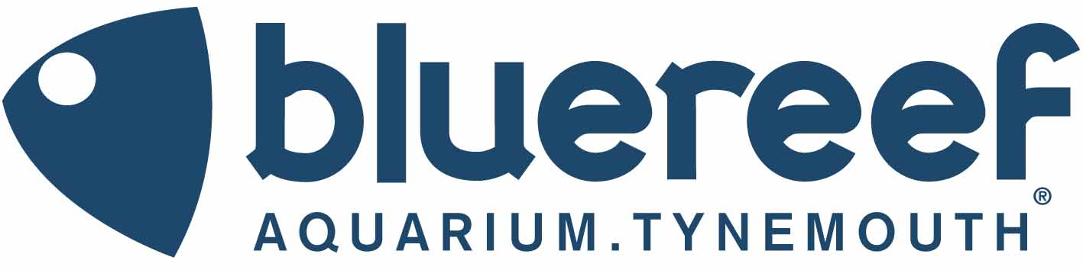

WORK EXPERIENCE APPLICATION FORM

To apply for work experience positions at Blue Reef Aquarium Tynemouth, please complete this application form.

Please ensure that you complete all sections of this form, failure to do so may result in your application being delayed or rejected.

Please note- we can only accept an application if you are aged 18 years or over.

- Personal Details
Title:
First Name:
Preferred Name:
Surname:
Date of Birth:
Home Address:

Home Telephone Number:
Mobile Number:
Email Address:
- Availability

What is your availability? From ____/____/____ To ____/____/____/

Which days are you available-

MONDAY TUESDAY WEDNESDAY THURSDAY FRIDAY

SATURDAY SUNDAY

Do you have any holidays booked?

YES From____/____/____ to ____/____/____

NO

- About You

Why would you like to join our Work Experience Programme?

- Any Other Information

Please add any other information which you feel may support your application.

2. Pre Application Questions
Before completing this form, please answer questions a) and c) below.
5. Education/Training Relevant to the Position Applied for

